ForeFuel Simulator

# General

ForeFuel Simulator is to be used by sales to demonstrate the VIS capabilities.

* Nozzle demo – mockup – light no metal – to mimic real nozzle look on shape and colors
* nNR – mounted on nozzle
* WGT
* Various rings (no DP)
* Simulation application

# Setup

* Extract the supplied ZIP file (ForeFleetSimulatorPack.zip ) to a folder (one time action)
* Double click on the font file " LiquidCrystal-Normal.otf " for install (one time action). The following window will open – click the install button.  
  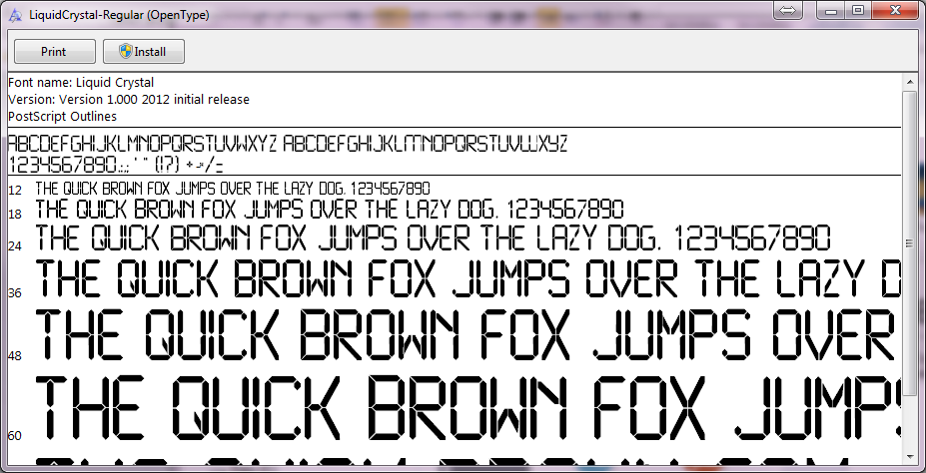
* Connect WGT LAN cable to laptop – configure network – open control panel -> network-> network connections  
  Double click Local Area Connection -> Properties -> Internet Protocol version 4.  
  Select 'Use the following IP address' and entre IP address and Subnet mask as show.

Press OK and close all dialogs.  
Note that to change back to original setting open the same dialogs and select 'Obtain IP address automatically'  
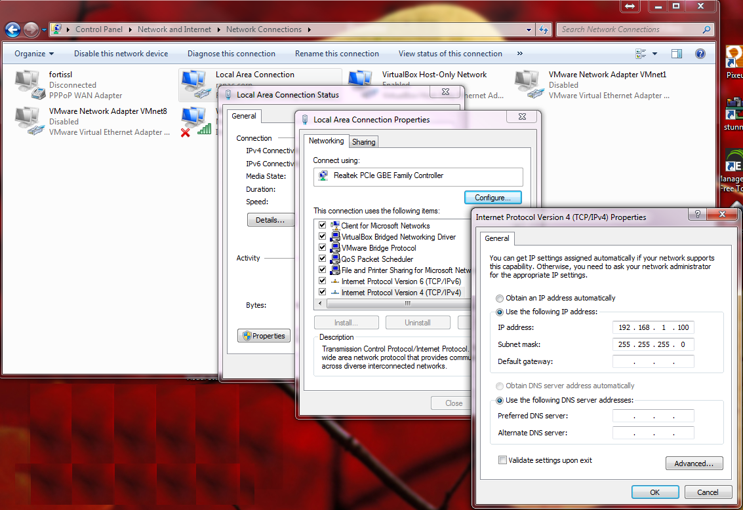

* Run the application " ForeFleetSimulator.exe "

## GUI

The GUI display the following information

* Two nozzles with their product name and price. User can click a nozzle ICON to 'lift' nozzle. User can not lift nozzle if other nozzle is up. The 'down' nozzle position is in gray while up position is in blue.
* Pump data. Shows the running sale values, both money (sale) and volume are shown. During fueling the numbers are running according to the defined flow rate and relevant product price. After transaction is done the values of last sale will be show until 'reset' by new transaction.
* List of five (5) last actions, last action is on top
* Vehicle identification. The plate of the current running transaction is shown as soon as the fueling starts. It will be cleared after transaction ends.
* Limit. The limit of the current running transaction. It can be volume to money limit. The limit will be cleared when transaction ends.

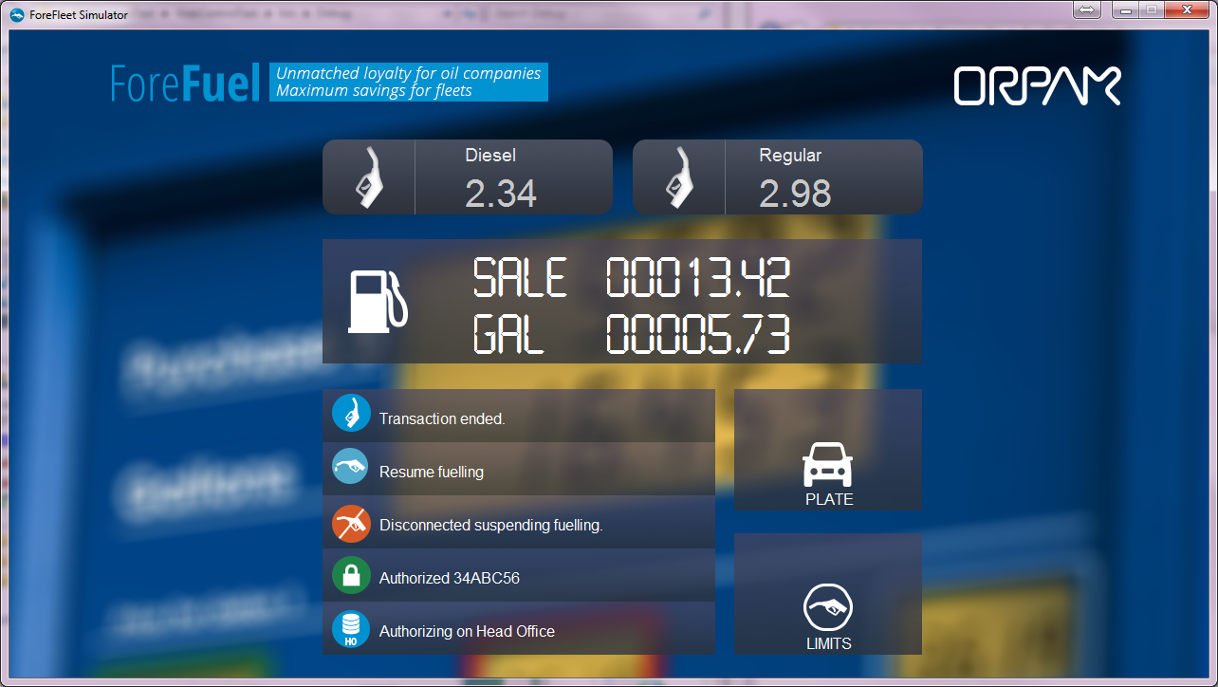

# Operation

* If WGT is connected proper message will be shown
* Nozzle should be listed before authorization (only one nozzle can be listed at any time)
* Connect FP to NR
  + After detection application will simulate access to head office to get authorization
  + If the device is defined to have cPass system will send auth request and will do 'retry' as defined
  + After getting authorization, if authorized, pump will be reset, show 888888 and after delay start fueling
  + During fueling motor sound is played and volume and sale are advanced
* Pump will stop when reach limit
* If FP is removed fueling will be suspended – when FP re attached fueling is resumed
* When nozzle is down transaction is ended
* New transaction, authorization, can start only after the FP is disconnected and connected again
* If during transaction other FP is detected fueling is suspended.
* If WGT is not connected proper message is show – any fueling will be suspended

## Configuration

An XML file is used for configuration of many parameters. It can be edit by any text editor (e.g. notepad). Be careful to change only the date between XML tags and not any other character as it will prevent proper reading and application will not load. It is advised to make a backup of the file before any change.

Using these parameters one can change some text and names to fit local language (note that the action list text is not configured)

The configuration file name is 'config.xml'

The following table lists the parameters, there meaning and allowed values.

|  |  |  |
| --- | --- | --- |
| Parameter (XML tag) | Meaning | Values (default) |
| IP | WGT IP address | Valid IP address (192.168.1.214) |
| Port | WGT port | 3000 |
| Addr | WGT serial address protocol | 32 (HEX) |
| Sound | Enable pump motor sound | true | false |
| PPV1 | Product 1 price | Float (2.34) |
| PPV2 | Product 2 price | Float (2.98) |
| Prod1 | Product 1 name | Diesel |
| Prod2 | Product 2 name | Regular |
| FlowRate | Pump flow rate (volume) | In Ltr / minute (40) |
| LimitText | Text on limit pane | LIMITS |
| PlateText | Text on identification pane | PLATE |
| Units | Volume units on pump pane | GAL |
| LimitPerVolText | Test to append to volume limit | L/Tnx |
| LimitPerMoneyText | Text to append to money limit | $/Tnx |
| PumpAuthDelay | Time delay to show 888888 | In mili seconds (1500) |
| HOAuthDelay | Time delay to check auth on HO | In mili seconds (2000) |
| Device (rings) |  | Can have multi sections |
| Enabled | If device is allowed or blocked | true | false |
| CardNum | The number on the ring | As per provided rings |
| Limit | The value of the transaction limit | Integer (10) |
| Type | Type of limit | Volume | Money |
| Plate | Plate of vehicle | Can be set at will |
| Prod | Allowed product | Match product names |
| CPass | Flag if this device should get mobile confirmation | true | false |
| CPass |  |  |
| Server | cPass server host name | Host name |
| Key | Token key given for station | string |
| Retry | Number of retries to get mobile approval before fail | Integer |

# Logs

Two log files are available. These logs should be provided with each report on any problem.

The logs files can be erased manually before running the application in case their size get big.

* "App.log" – Application log with all operations
* " VITComm.log " – WGT communication log